Tricopter Selfie Drone

We have entered a digital age where taking better selfies means a lot to individuals. But taking selfies is either limited to length of ones arm or an extended selfie stick. Well we unlock this limitation with our innovative selfie drone.
The drone consists of a wireless camera that allows user to click his/her selfie from a whole wide variety of angles including from top from far away, far to closeup zooming videos, family selfies, group selfies, group videos and a lot more.
So to make this system we start with a drone frame. The frame isa tri sided one so that we can attach 3 arms to the frame. Each arm is fitted with a BLDC high torque motor and a propeller. These motors are now connected to the controller through esc’s.
We now use a controller to controller the motor with commands received through an integrated receiver antenna. The controller receives commands and operates the rotors to achieve the required flight. We here attach a camera that can be operated wirelessy through android phone.
The camera footage can be monitored by user and user can also click photos as well as videos through the dron camera using his/her android phone. Thus the project allows for a fully automated remote controlled selfie drone tricopter.
Components
- Drone Motors
- Propellers
- Drone Frame
- Camera Mount
- Wireless Camera
- Brushless Motors
- Drone Receiver
- Drone Controller
- Transmitter Remote
- PDB
- Resistors
- Capacitors
- Diodes
- LED’s
- Transistors
- Connectors & Cables
- PCB
- Supporting Frame

Applications
- Individual Selfies
- Group Selfies and Videos
- Wedding Videos
- Corporate Videos
- Stock Videos
- Event Filming

Advantages
- Instant Selfie
- Ariel Angle Selfie
- Live Footage for Review

Advantages
- Limited Flight Time
- Limited Range

Block Diagram
Front View
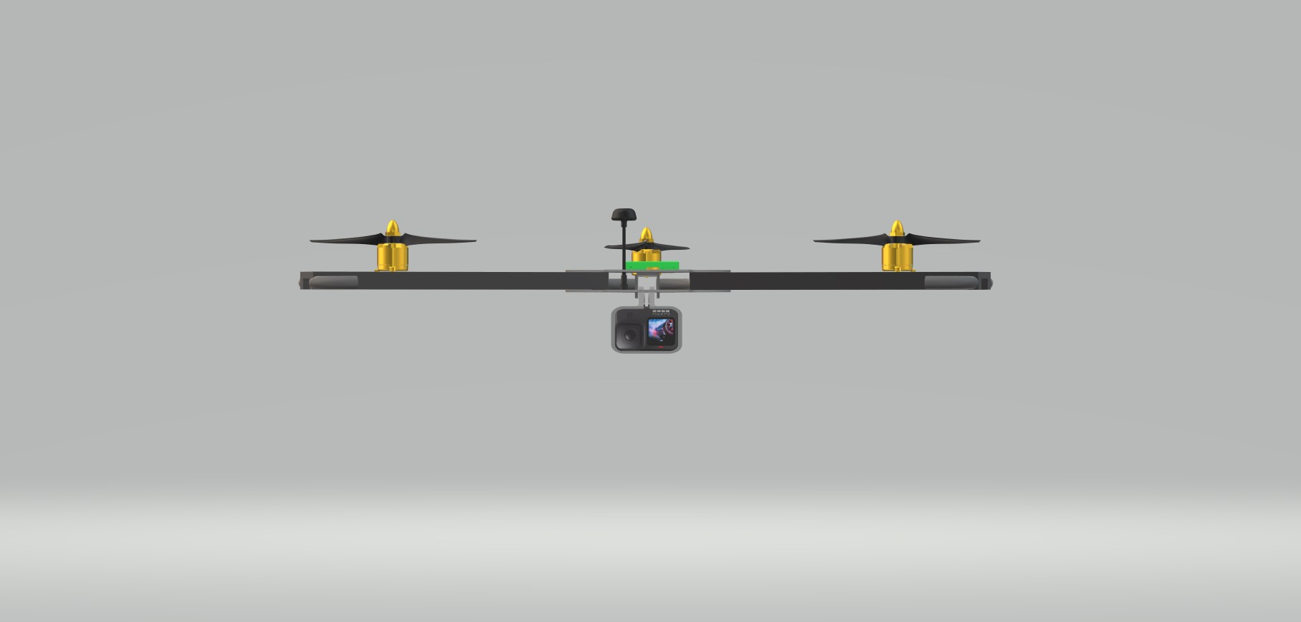
Side View
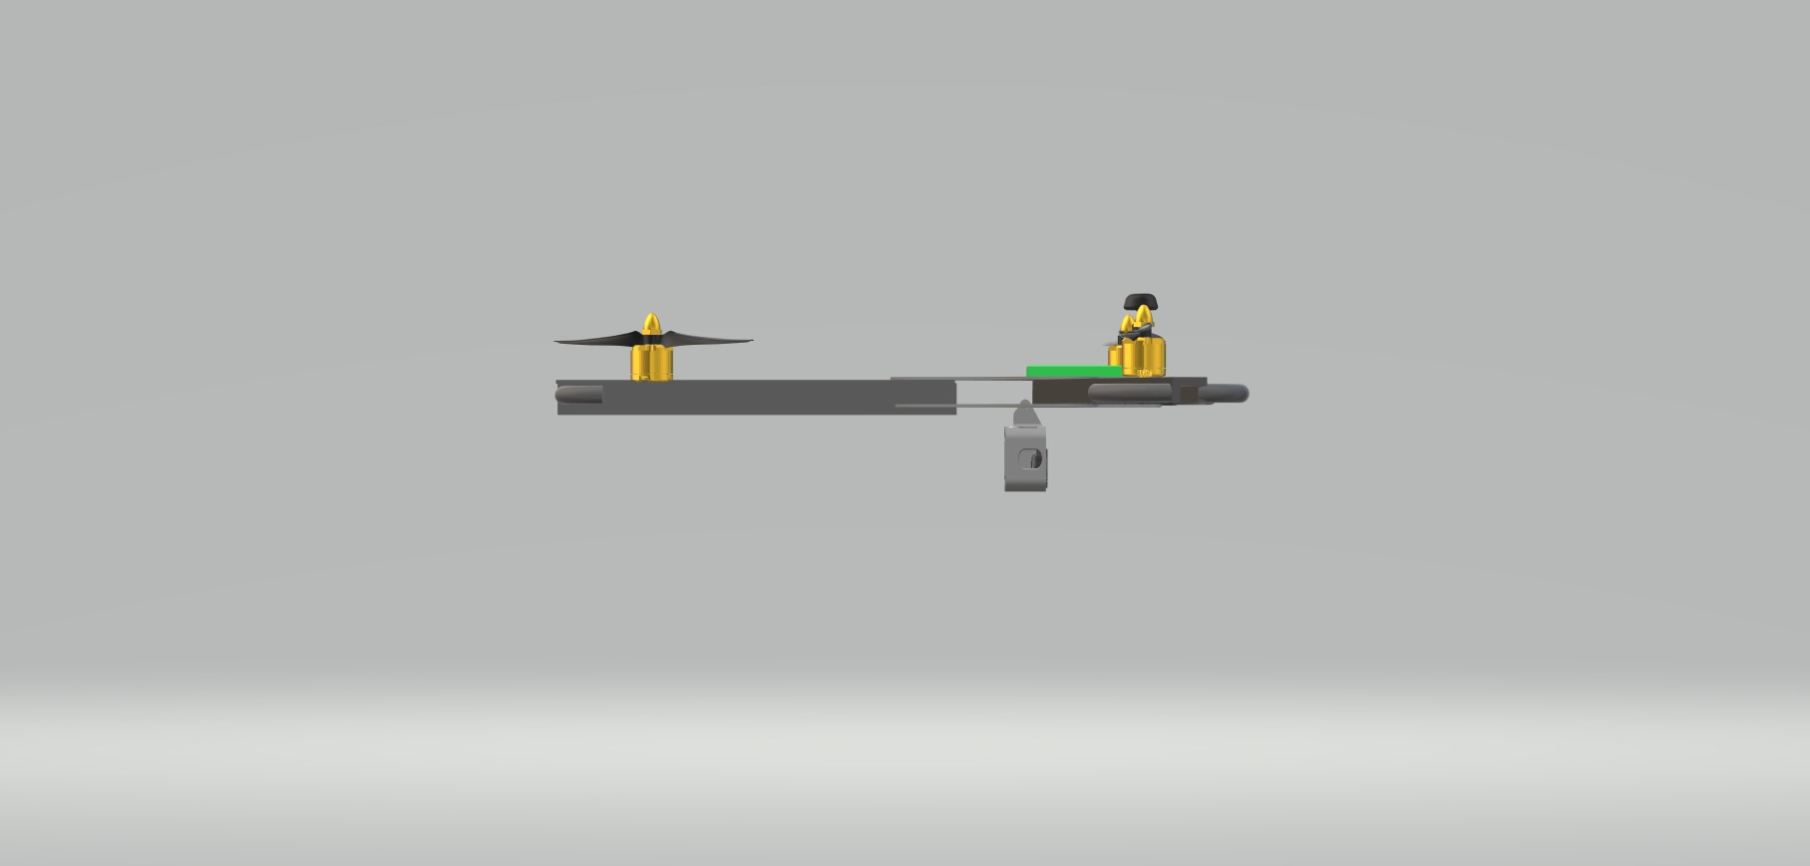

3D View
